Declan Sheehan

Dr. Anderson

COSC320-001

5 December 2019

Lab 11 ReadMe

Summary:
I started off with the previous code created in Lab 10, then I reviewed the notes for DFS, and topological sort to create the other functions for this lab. This lab I had to use more of the standard library functions such as map, stack, queue, and list.

Time Complexity:
- Depth First Search is: O(|V| + |E|).
- Topological Sort is: O(|V| + |E|) too.
- Strongly Connected Component is: Θ(|V| + |E|) too.

Code Improvements:
Fixing the SCGC (Strongly connected graph component) function would be good. (At least I believe it is broken).

It could also be templated, however; ain’t nobody got time for that!

Test graphs used:
Test 1 Test 2
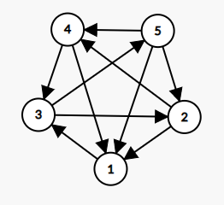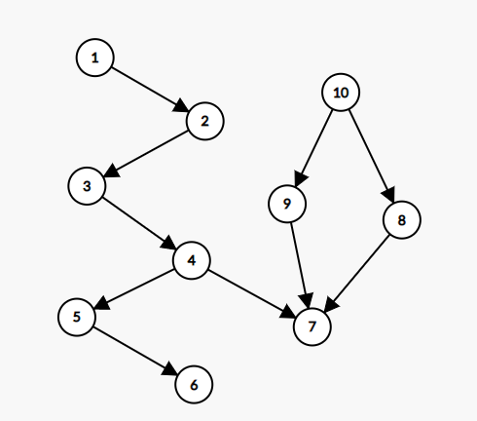
-Created using: https://csacademy.com/app/graph_editor/

